Ex.1: Design a LED flasher

Circuit diagram -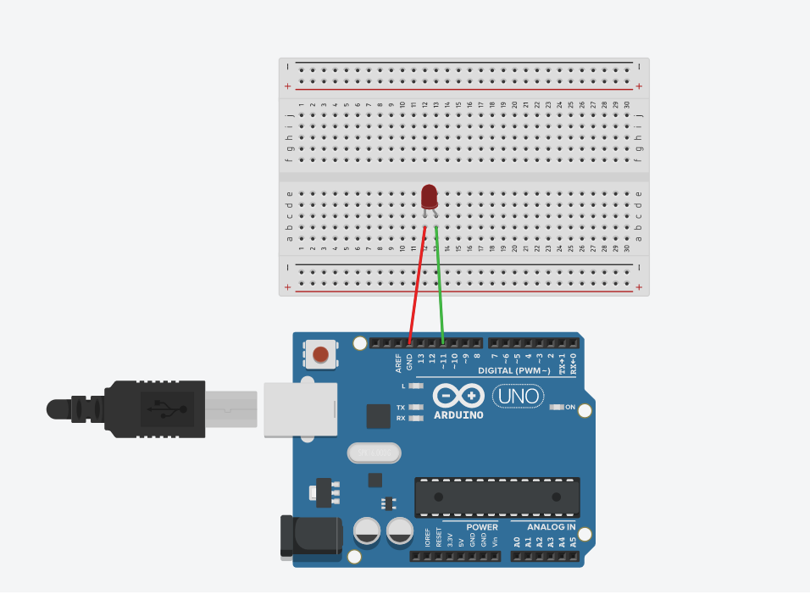

Theory

Concept Used: We will use a standard arduino board and connect it so that it flashes an LED a certain amount of times on and off repeatedly to create an LED flasher circuit.

To build this circuit, we simply connect the anode of the LED (the longer of the 2 ends) to digital pin 11 of the arduino board and the cathode of the LED to the ground Pin of the arduino board with the help of breadboard.

The circuit connected will look like above circuit diagram.

Once the circuit is connected in this way, all we have to do is take the USB connector and plug the type A connector into the computer and the type B connector into the arduino board.

Learning & Observations:

1.Using Arduino UNO.

2.How to make LED flasher using Arduino.

Problems & Troubleshooting:

1.There can be problem with biasedness of LED(anode and cathode).

How to solve it:

The side which has long wire or when we see inside LED there are 2 silver part part which having small portion is anode and the other one is cathode.

Precautions:

1.Connections should be tight.

2.LED’s cathode should be connected to ground and anode to the pin assigned(in above case its 11).

Learning Outcomes:

1.Using Arduino UNO.

2.How to make LED flasher using Arduino.

3.How we can use LED using microcontrollers.